Spark Ministries - Albania
Prayer and Praise Points December 2020:
Praise Points:
1. Thank God for the new van outreach - ‘More than a Superhero’ project that has been doing outreach around the nation, most weekends between mid-Sept – mid-Nov, helping local churches to carefully restart their children’s ministries.
2. Thank God that our online children’s ministry, ‘Shkëndijë Kids’ on Facebook is growing at a steady pace, with on average over 150 new followers each month.
3. Thank God for Vali being able to re-gather the small children’s discipleship groups in Shengjin.
_________________________________________________________________________________
Prayer Points:
1. Please pray in the midst of Covid-19 the Albanian church will find creative and safe ways of reaching out to children this Christmas, and that the covid-19 rule of not gathering with more than 10 will soon be relaxed. Pray for the launch on Jan 1st of our new online children’s daily devotion.
2. Please pray as we seek to strengthen our foundations and infrastructure to support growth and more effective ways of serving this nation. (The Lord spoke to me a while back: Isaiah 54:2 “Enlarge the place of your tent, stretch your tent curtains wide, do not hold back; lengthen your cords, strengthen your stakes...”). Pray for the funds to enable the setting up the new online finance system (QuickBooks) and an exciting new Albanian website, which will help us manage expansion and the equipping local church better for children’s ministries.
3. Please pray with us also as we meet as a board mid-December (18th) to discuss some important decisions moving forward.
_________________________________________________________________________________
May God bless you greatly this Christmas time!
With thanks and prayers,
Rachel and the ‘Spark’ team.

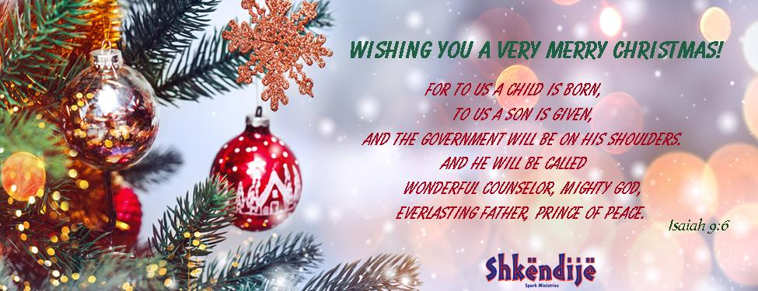 WWW.SPARKMINISTRIES.ORG

